Data Sheet
Product Information
Product Name | : | Recombinant Human Epidermal Growth Factor (rhEGF)
Synonyms | : | Pro-epidermal growth factor, Urogastrone
Description | : | Epidermal growth factor (EGF) is a growth factor that stimulates cell growth, proliferation, and differentiation. Human EGF is a 6045 Da protein with 53 amino acid residues and three intramolecular disulfide bonds. EGF acts by binding with high affinity to EGFR on the cell surface. This stimulates ligand-induced dimerization, activating the intrinsic protein-tyrosine kinase activity of the receptor. The tyrosine kinase activity, in turn, initiates a signal transduction cascade that results in a variety of biochemical changes within the cell - a rise in intracellular calcium levels, increased glycolysis and protein synthesis, and increases in the expression of certain genes. (Ref. From Wikipedia)
NCBI Accession No. | : | NM_001963.4
Amino acid sequence | : | MNSDSECPLSHDGYCLHDGVCMYIEALDKYACNCVVGYIGERCQYRDLKWWELR
Molecular Mass | : | 6.33 kDa (54 aa)
Protein Tags | : | No tagging
Source | : | E. coli.
Cat. No. | : | JW-H010-0050, JW-H010-0100, JW-H010-0250, JW-H010-0500, JW-H010-1000
Storage | : | Should be at ≤ -70 ℃ as undiluted aliquots of handy size. Avoid repeated freezing and thawing.
Cross Reactivity | : | Mouse, Rat, Monkey, Rabbit, Pig, Cow, Hamster

Quality Control
Test items |  |  |  | Specifications
Appearance |  |  | : |  | Clear, colorless liquid
Purity |  |  | : |  | Greater than 95 % by SDS-PAGE
Specificity |  |  | : |  | Using Western blot, detection | 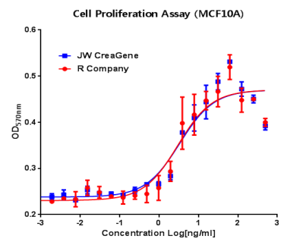
Concentration |  |  | : |  | 0.1 mg/㎖, Bradford method
Biological Activity |  |  | : |  | Determined by proliferation of MCF10A indicator cells.  The ED50 is <100 pg/ml, corresponding to a specific activity of > 1.0 × 10⁷ U/mg
Endotoxin |  |  | : |  | Less than 0.5 EU/㎍ as determined by the LAL method
Formulation |  |  | : |  | PBS (pH 7.4) without preservative or carrier proteins.
Stability |  |  | : |  | Stable for up to 12 months at -70 ℃. Stable for a month at 4 ℃.
Sterility |  |  | : |  | Sterilized through a 0.2 ㎛ membrane filter and packaged aseptically. Culture for 2 weeks, no growth

